Project Design Phase
Solution Architecture

Date | 20 February 2025
Team ID | LTVIP2026TMIDS41763
Project Name | ShopEZ:One-Stop Shop for Online Purchases
Maximum Marks | 4 Marks

Solution Architecture:
Solution architecture connects the business problem (lack of a secure ecommerce platform) with a technical solution (ShopEZ system).
Its goals are:
- To provide a secure and scalable ecommerce platform for users and sellers.
- To define how frontend, backend, database, and payment systems work together.
- To identify features like authentication, product management, cart, orders, and payments.
- To define the technologies used (React, Node.js, MongoDB, Razorpay).
- To ensure the system is secure, scalable, and easy to maintain.
Solution Architecture Diagram:
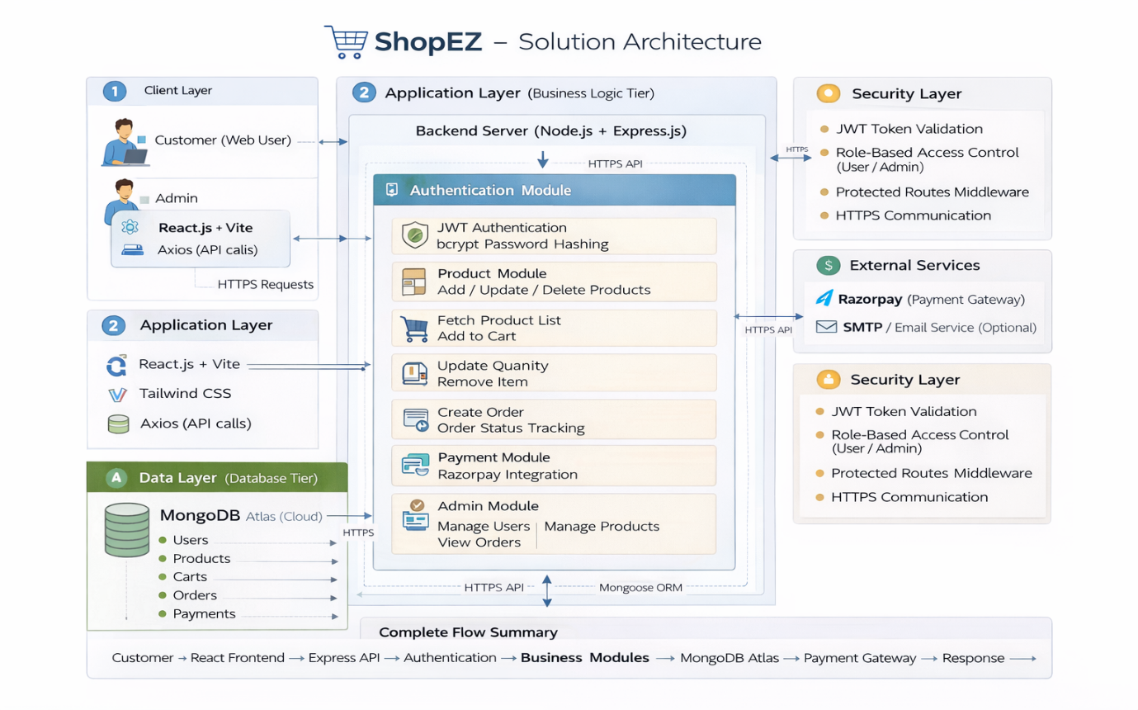
Figure 1: Architecture and data flow of the voice patient diary sample application
Reference: https://aws.amazon.com/blogs/industries/voice-applications-in-clinical-research-powered-by-ai-on-aws-part-1-architecture-and-design-considerations/

